 CCOPA NEWS Winterish 2025
For Citizens On Patrol and Crime Watch Volunteers
________________________________________________________________________________________________________________________________________________

Off the top, I am attempting to make this newsletter one with C.O.P. news as well as a few lines on the lighter side and possibly unknown to some of us. It is not a format such as Alberta has – they have the best read about individual groups and activities. This one is just different!
Just reading over the last newsletter which was called Winterish 2024 where I noted that in the west, it was “way too warm” with little snow on the hills. Well, what a difference a few months makes. British Columbia and where I live on Vancouver Island is noted for likely the best overall weather (many people retire here), so here I sit looking at the 12-14 inches of snow the last (Sunday -Tuesday) few days. I have never seen so many snowblowers on a residential road in my life and I lived in Kitimat, BC where record snowfalls are the norm!!!
Life is interesting and it proved that if something is important, it’s worth fighting for. Several years ago, Manitoba had a good C.O.P. group where we held our national conferences several years and where Bev and I first met to discuss the formation of CCOPA. Then the Manitoba Board changed direction and had no interest in being part of CCOPA. Now after our temporary contact Tracey kept her contacts interested, we made elected her the permanent to represent Manitoba and now it looks like the Winnipeg group is interested again. We only have Quebec and Newfoundland and Labrador and our friends in the Yukon and Northwest Territories where we need to spend some time and energy. _________________________________________________________________________________________________
Thanks
To the following groups who recently responded with support, we thank you. The donation you have made will allow CCOPA to take further steps in providing the best source of learning materials to reinforce the strength of the local groups. We urge others to follow the lead here to make a small donation anytime. To better understand your community, here is a little tidbit about each of you.
Recent donations from:
High Prairie COPs. Located northwest of Edmonton with a 2021 population of 2,380. Wood industry supports the town. Named part of Big Lakes County.
The Battlefords COPs. The Town of Battleford, population of 4,400 (2021) and City of North Battleford, population of 13,836 (2021).
Ryley COPs. 75 km east of Edmonton. In 2020, the Ryley Solar Project was completed to power all commercial buildings. Population in 2021 was 484 persons.
Drumheller COPs. Located on highway 9 in the “badlands of east-central Alberta.” Population in 2021 was 7,909. Known for a 86ft high dinosaur, the worlds largest. Got to see it!
Fort McLead COPs. Located in southern Alberta through which highway 3 from BC and highway 22 from Calgary pass. Population in 2021 was 3,297. Houses Museum of the Northwest Mounted Police. Large wind farm near by.
Yorkton COP. Located 450 kms NW of Winnipeg and 300 kms SE of Saskatoon. Population of 16,280 in 2021. Connected with Highway 16 the Yellowhead which crosses into BC.
Rimbey and District C.O.P.s. Town of 2,740 (2021) located in central Alberta 62 kms NW of Red Deer. It is the rural gateway to thriving mixed farming and oil and gas. It has the world’s largest collection of International Trucks in their Museum.
_____________________________________________________________________________
A VOLUNTEER
We have each probably noted that there are many groups, other than police related groups, who are suffering from a lack of volunteers. But with our C.O.P. groups, many of us volunteer for more than one group and you should be commended for that. With the forming of their the Saskatchewan provincial association, it is noted that one such volunteer has come forward. She is the Battlefords COPP Secretary (Melanie Roberts) who received the King Charles III coronation medal recognizing her volunteer service with many organizations, including the Battlefords & District Chamber of Commerce.
On Feb. 6, 2023, she and eight other residents were honoured with the prestigious medal for service to Saskatchewan in various fields.

In the following picture, the 13 recent North Battleford recipients of the Queen Jubilee are shown with Cst. Karl Nehring, Cst. Jessica Maclean, Mayor David Gillian, Councillor Kelli Hawtin and Councillor Kent Lindgren.
Original article written by Miguel Fenrich / Feb 7, 2023 6:59 PM

….and we congratulate Melanie as well. You no doubt are a great contributor to The Battlefords and the Saskatchewan Provincial Association.

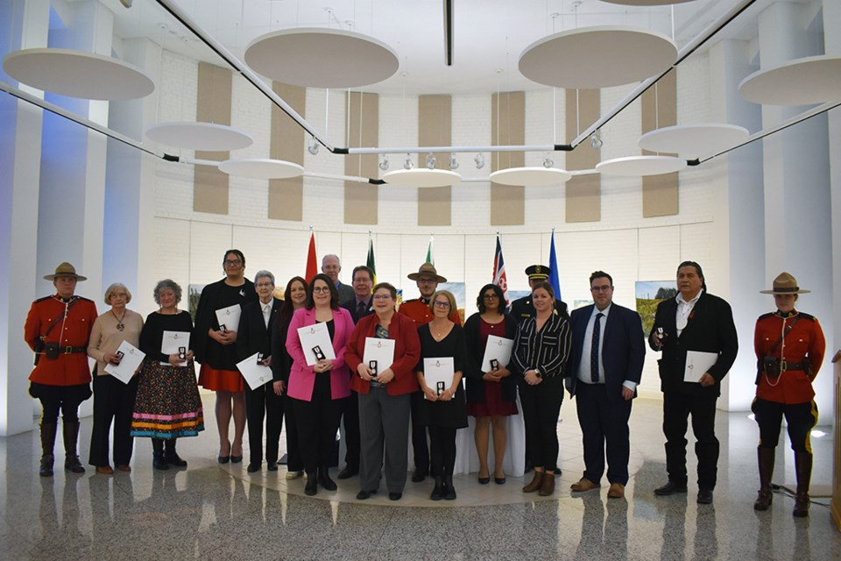

_____________________________________________________________________________
DID YOU KNOW?
At each CCOPA meeting, our provincial representatives make a short report on happenings in their province. area. Besides bringing forward information on the number of volunteers in their province, they bring news about new initiatives and interaction with police. Some provinces are very active with a strong provincial association and others have a difficult time. This is not because of not trying, but the general atmosphere in assisting with the organization of a provincial association is not evident. At every step with a volunteer organization, the police have to be involved in leading the way and if not, then the idea will fail.
The following is an example of strong commitments by several municipal police forces in Ontario; however, the idea of forming a provincial association has not progressed.
Wayne Cameron, Ontario representative has stepped forward with news from his C.O.P.s group who with the support of all the police agencies and community supporters strive on everything new and exciting to bring to our group. Wayne is a member of the Barrie C.O.P. who have tremendous support from the Barrie Police Services. The group in Barrie continues to strive in achieving their goals and are also currently supporting training and recruitment to the Greater Sudbury Police Service C.O.P. program which was stuttered during the pandemic. Wayne tells of the Police Volunteer Coordinator restarting the program by canvassing part volunteers and others who have gone into the community to give talks, scheduling mobile radar training, and implementing speed watch, stop sign watch, and noise watch in 2025.
Here is what a Barrie C.O.P. vehicle looks like, nice and bright with permanent high visibility markings.
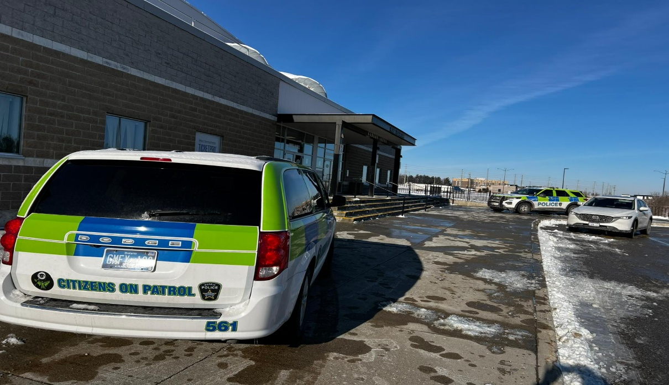
Another worthwhile project that has been researched deals with emergencies we seem to suffer from each year. Remember wildfires in BC and Alberta or the recent California stories. It takes volunteers to be available to assist in these cases of provincial and state emergencies. In Ontario, there is a program called Ontario Corp Volunteer Program (started in 2025) which provides training in four areas. Wayne has taken the courses (online) and suggests it might be something for all of us to consider. Certificates are awarded on successful completion.
An overview of the program is “a group of partners and people that the government can call to help communities hit hard be emergencies and natural disasters.” This includes equipment as well as tasks such as sandbagging, serving meals and the like. To be eligible in Ontario, you must be 16 years, a resident of Ontario, complete a CRC, and complete free training on-line.
The four courses to be completed are:
- Emergency Management and Preparedness
- Emergency Volunteer Risk Management
- Accessibility and Human Rights
- Exploring the Roots of Racism
The idea for C.O.P. volunteers is to gain additional exposure for our program. If people are interested, go to the Ontario Corp website or contact Wayne directly.
_____________________________________________________________________________
CCOPA – Annual General Meeting
As a result of our recent Annual General Meeting, the Board of Directors has again been solidified by the addition of Tracey Proctor from Manitoba.
As to the CCOPA Board, we have brought back the Executive members to serve another term. They are the President Bev Salomons from AB, Vice-President Martin Perry from PEI, and Brian Cornborough from BC to fill the Secretary/Treasurer position. Collectively, a fair number of years for the three of us - you have made it easier for sure.
As noted earlier, Manitoba did not participate for several years. but with her hard work, it seems the group is rethinking their decision and were guests at our recent meeting. At the CCOPA February meeting, two board members from Manitoba Citizens On Patrol were welcomed as guests.

_____________________________________________________________________________
ONE THOUGHT – MY THOUGHT
With the constant change of personnel within the RCMP and not so much with any of the municipal police forces we are lucky to deal with, we need your eyes and ears to let us know of those changes. For example, when a new detachment commander is named for you, please let me know so that we can send them a letter of congratulations. The same would be where other management personnel such as a Community Policing Officer are named.
With the letter, we also provide other information so that they know who we are. Thanks.
____________________________________________________________________________________
DID YOU KNOW?
The Royal Newfoundland Constabulary (RNC) is the provincial police service for the province of Newfoundland and Labrador.
The Royal Newfoundland Constabulary is one of three provincial police forces in Canada, alongside the Ontario Provincial Police and the Sûreté du Québec. Uniquely, the responsibility for policing in Newfoundland and Labrador is not granted to municipalities. In Ontario and Quebec, the provincial police provide frontline police services only to small communities or at the request of a municipal council; in Newfoundland and Labrador, the Constabulary operates in all communities by default. Since 1949, the Royal Canadian Mounted Police have provided police services in the province's rural interior, in place of the RNC.^{[2]}
As of 2023, the Constabulary currently serves or is expanding to serve the northeast Peninsula (metropolitan St. John's); the Bay of Islands and the Humber Valley (metropolitan Corner Brook); and western Labrador (Churchill Falls, Labrador City, and Wabush).^{[3][1][4]}
The Citizens On Patrol program works with all law enforcement agencies, not just the R.C.M.P.

You are the key to program success…..

How much is a volunteer hour worth in 2022?
Each year, Independent Sector gathers data and conducts research on volunteerism in the nonprofit sector. The results of that research provide nonprofits a way to calculate the value of volunteer time. As of April 2022, their estimated national value of each volunteer hour is currently $29.95, up $1.41 since last year.

How much money do volunteers save in Canada?
We estimate that volunteers added over two billion hours to Canada’s work effort in 2017. This volunteer contribution is valued at $55.9 billion in 2017—equivalent to 2.6 per cent of GDP. If volunteering were an industry, it would employ nearly as many people as those currently working in education.

What are good incentives for volunteers?
- Catered volunteer luncheons.
- Annual or semi-annual volunteer awards.
- Certificates or acknowledgment from the mayor’s office.
- A carnival or festival for volunteers and their families.
- Gift baskets or gift cards to volunteers’ favorite restaurants or stores.

How do you honor a long-time volunteer?
Bring in coffee and donuts
- Send flowers or a card for special days.
- Highlight a volunteer in every newsletter.
- Give new volunteers a welcome gift.
- Listen to your volunteers and actively seek their feedback.
- Host a surprise party.
- Celebrate with their entire family.
- Offer tickets to a game.
- Host a car wash.
_____________________________________________________________________________________
_____________________________________________________________________________________
Brian Cornborough, BC Representative CCOPA
Editor, BC and CCOPA Newsletter | Citizens on Patrol BC | briancornborough@gmail.com
C.2025.02.20 / www.ccopa.ca / FB

